**Project Planning Phase Milestone & Activity List**

|  |  |
| --- | --- |
| Date | 22 October 2022 |
| Team ID | PNT2022TMID11603 |
| Project Name | Smart Fashion Recommender System |
| Maximum Marks | 2 Marks |

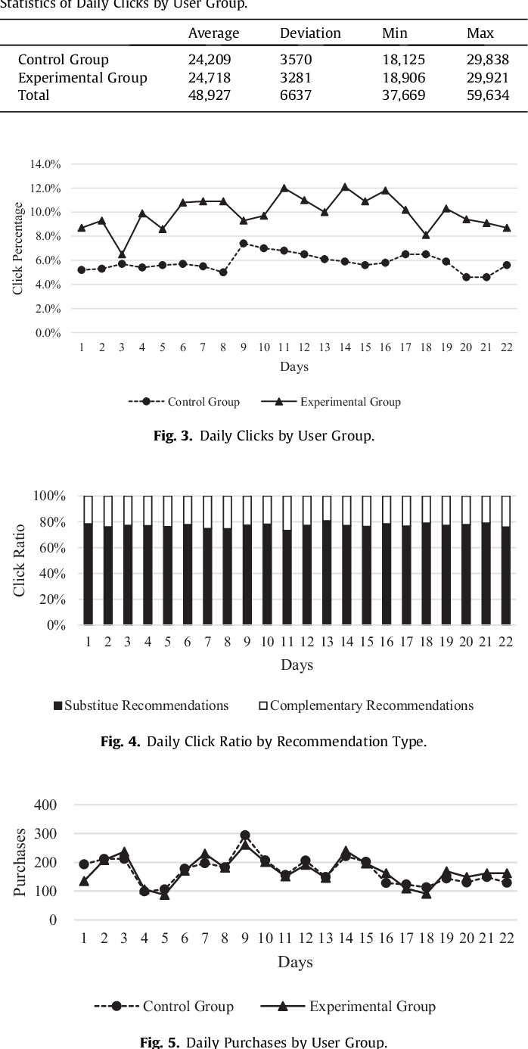

|  |  |  |
| --- | --- | --- |
| **Title** | **Description** | **Date** |
| Literature survey and Information Gathering | 8-10 Literature Survey Papers were studied and information were gathered from various IEEE papers | 8 September 2022 |
| Prepare Empathy Map | Using Empathy Map Canvas, user gains, and pains were gathered. | 17 September 2022 |
| Ideation | List by organizing the brainstorming session and prioritizing the top 3 ideas based on their feasibility & importance. | 18 September 2022 |
| Proposed Solution | Prepare the proposed solution document, which includes the novelty, feasibility of an idea, business model, social impact,  scalability of the solution, etc. | 27 September 2022 |
| Problem Solution Fit | Prepare problem solution fit document | 27 September 2022 |
| Customer Journey Map | Prepare the customer journey maps to understand the user interactions & experiences with the application. | 07 October 2022 |
| Solution Architecture | Prepare solution architecture document for clear perspective view. | 09 October 2022 |
| Solution Requirement | Prepare the functional requirement document as per customers concern.. | 27 October 2022 |
| Data Flow Diagrams | Construct the data flow diagrams to demonstrate the process | 27 October 2022 |
| Technology Architecture | A detailed description about the application including tech and non-techie used. | 27 October 2022 |
| Prepare Milestone & Activity List | The complete schedule for entire taskss. | 29 October 2022 |